Power Shell 101
Module 1A – Visual Studio Code (VSCode)
3/2/2019 Developed by Sam Chung
Center for Information Assurance (CIAE) @City University of Seattle (CityU)

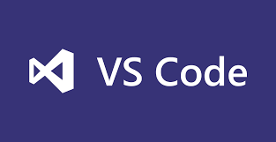
Learning Outcomes
- Learn how to install Microsoft “Visual Studio Code (VSCode)

Resources
- Visual Studio Code, https://code.visualstudio.com/
- Cmd commands under Windows, https://www.thomas-krenn.com/en/wiki/Cmd_commands_under_Windows

Activities
- Downloading
- Installing
- Testing
- Q&A

Downloading
- Visit https://code.visualstudio.com/
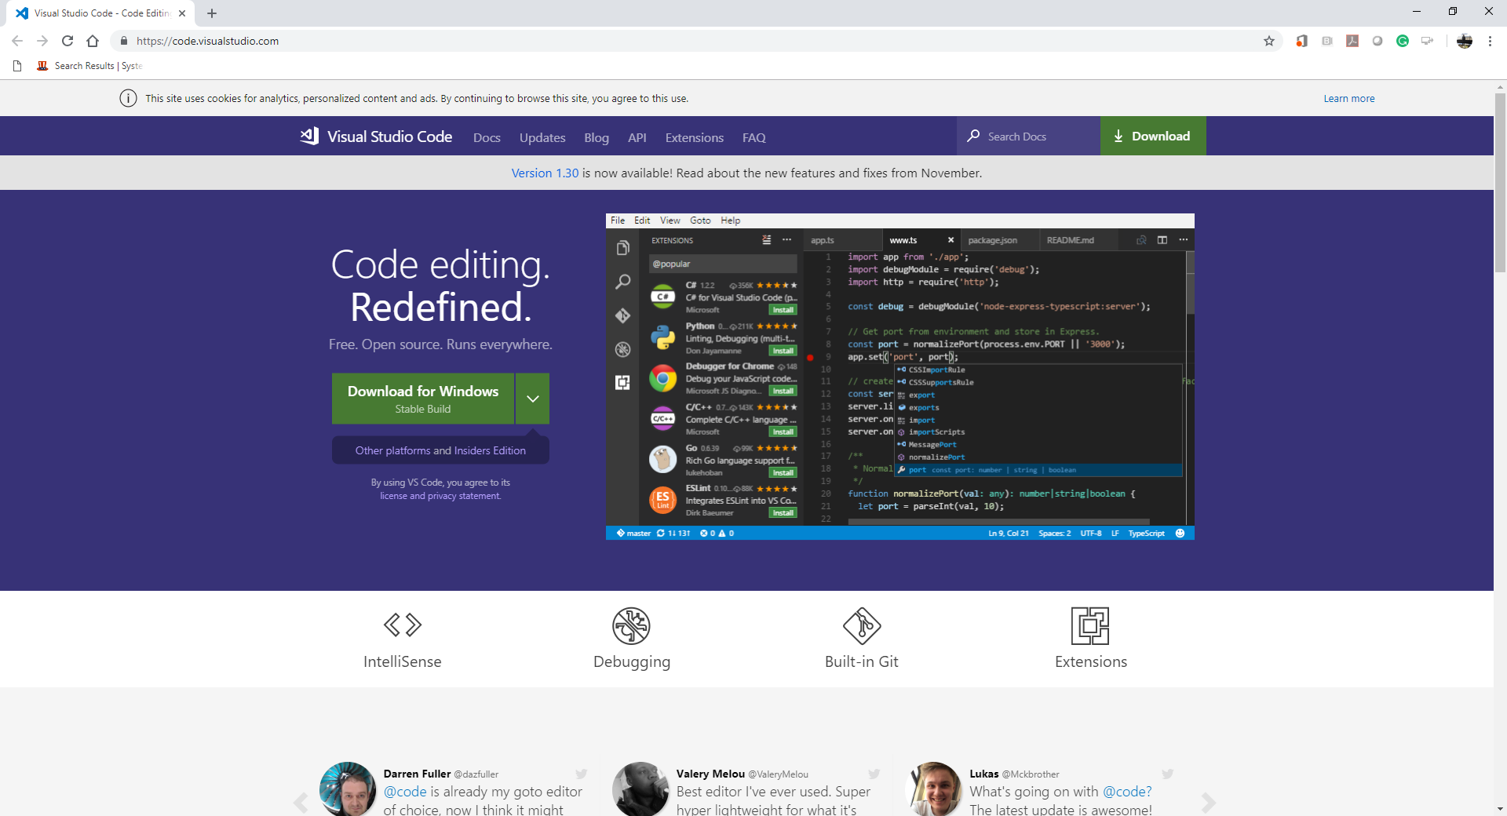

- Select a correct version for your operating system.
For example, you can select “Windows x64” for your Windows 10.
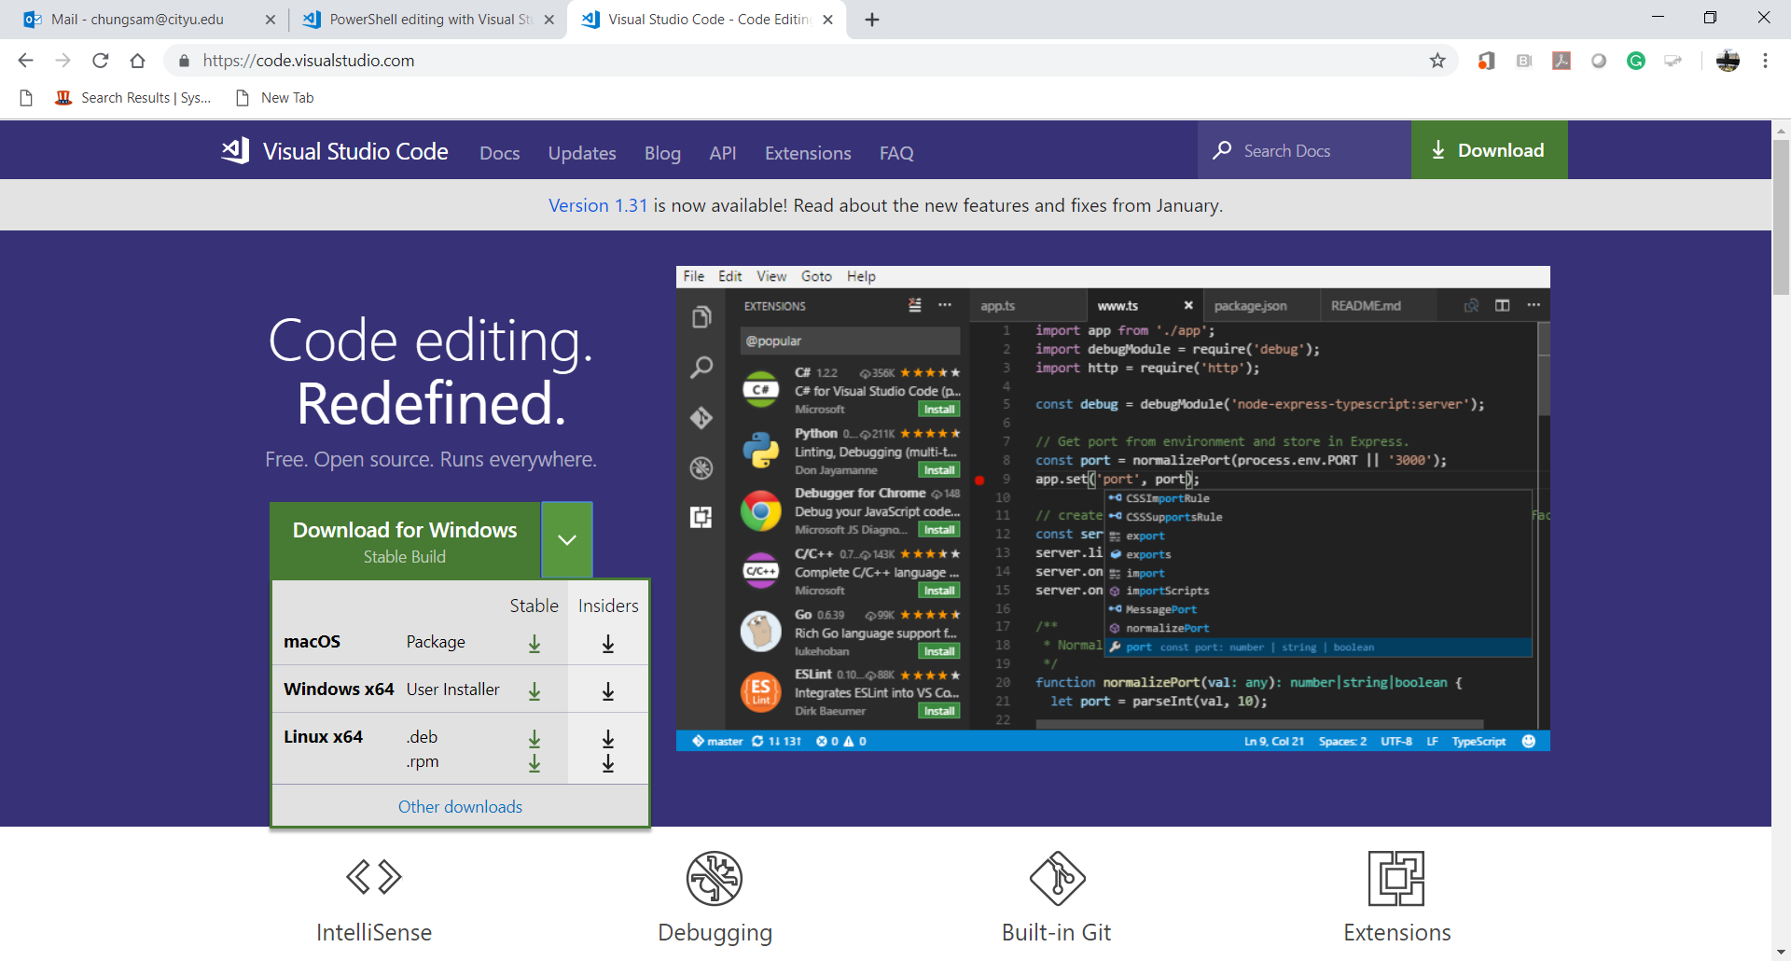

- Then, you can download “VSCodeUserSetup-x64-1.30.2” for your Windows 10.
- The “Getting Started” webpage will be displayed.
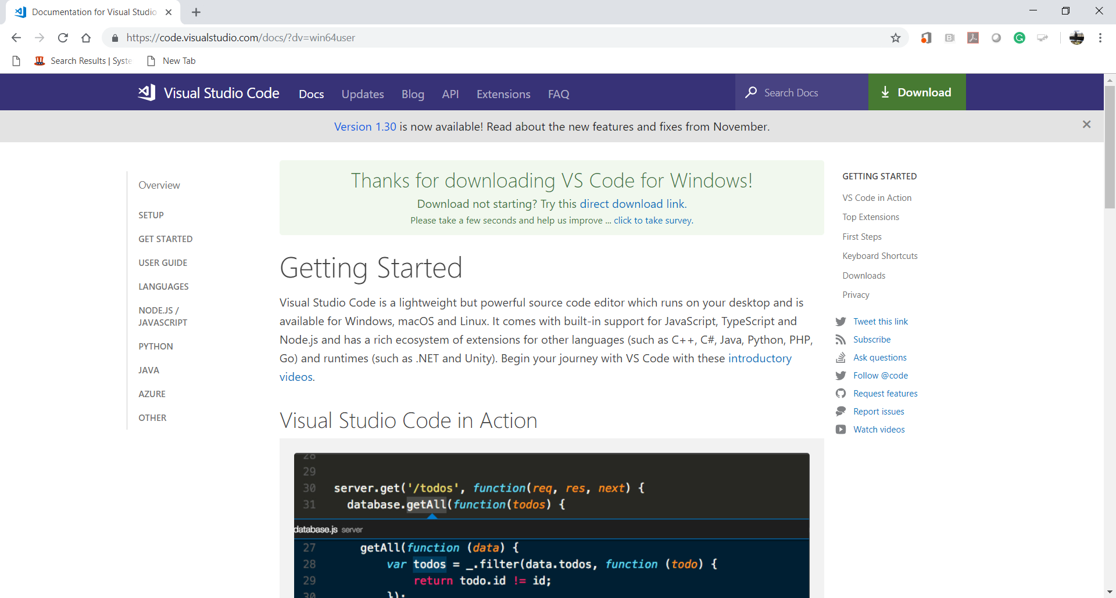

Installing
- Install VSCode.
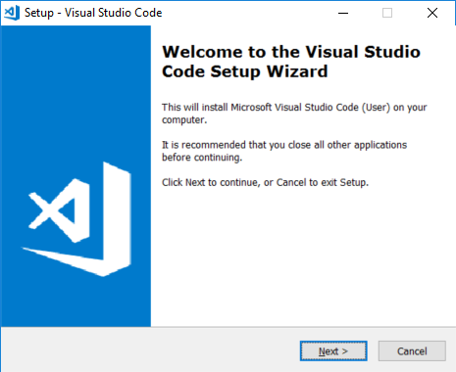
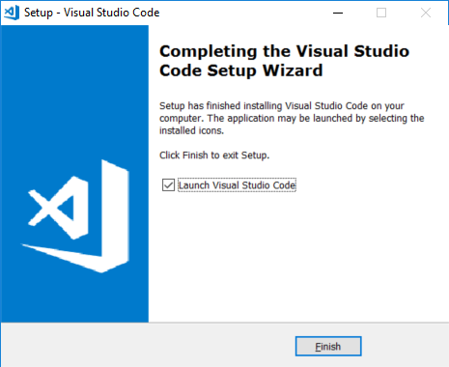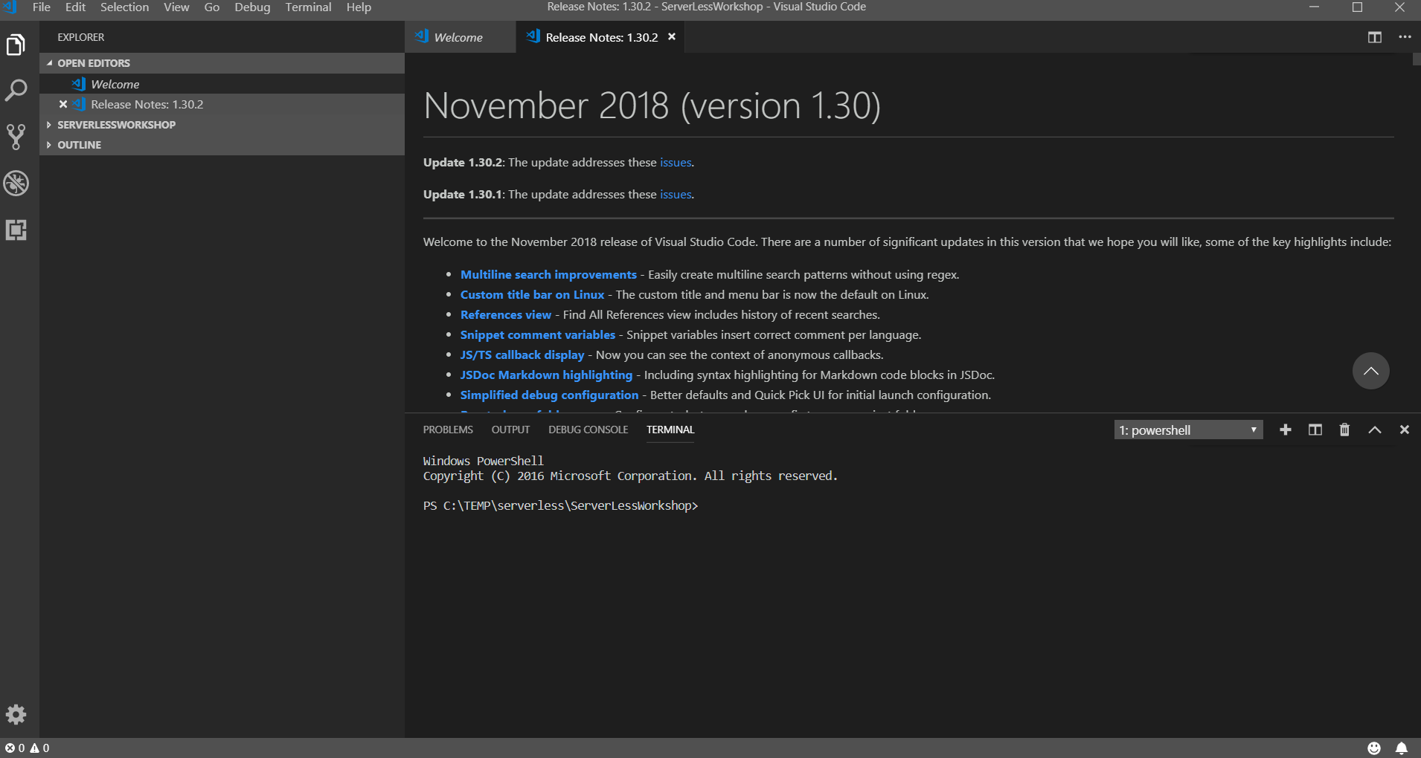

- After installing the VSCode, close the VSCode.
Go to “File” menu end select ‘Exit” menu item.

Testing
- Open the VSCode.
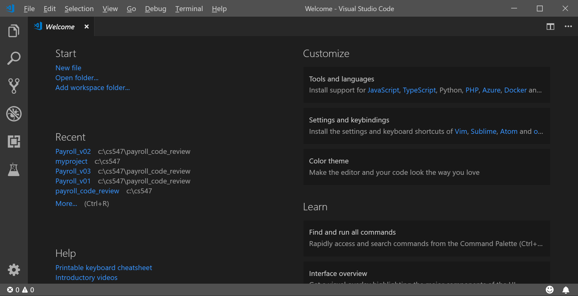

- Go to “View” menu and select “Terminal” menu item for your Command Line Interface (CLI).
Or you can type “Ctrl+~”
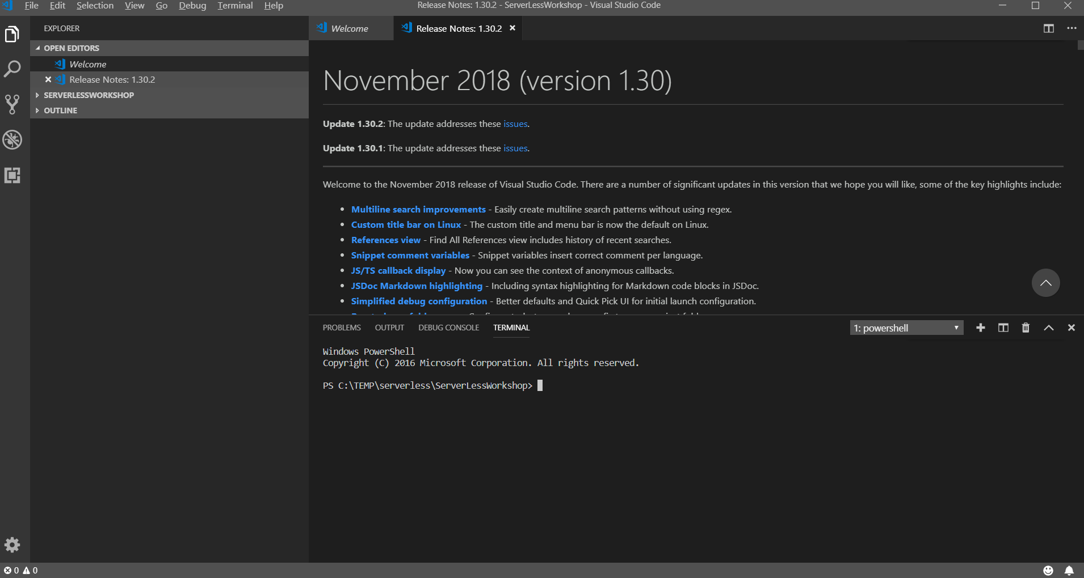

- Go to the root directory of your disk drive.
Create a working directory called “isec505” for your course and move to the directory.
The following commands under Windows will be used.
>> cd /
>> mkdir isec505
>> cd isec505
>> dir
For more information about Windows commands, please visit https://www.thomas-krenn.com/en/wiki/Cmd_commands_under_Windows
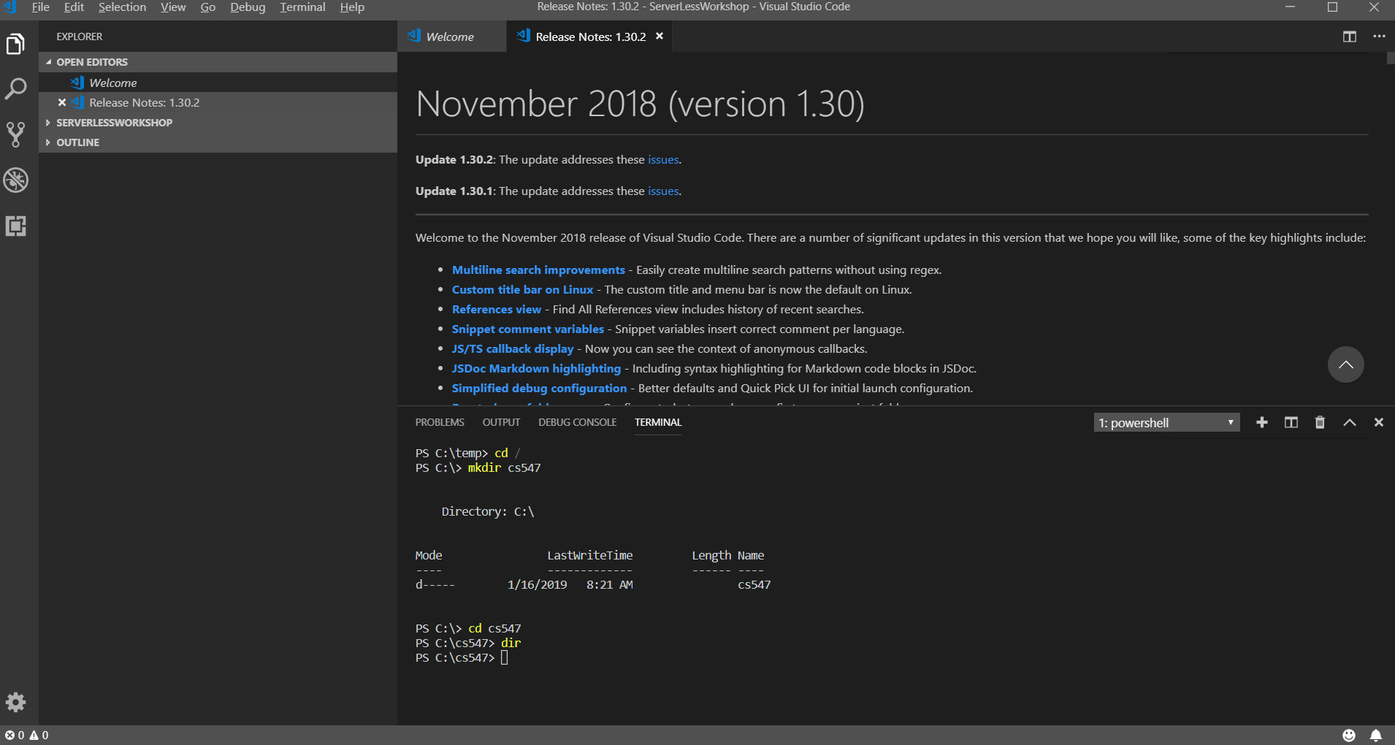

- Clear your CLI.
>> cls

- Close the VSCode.
Q&A
Justify your answers with at least one reference.
- What is Visual Studio Code?
The Visual Studio Code is a source code editor that available on MacOS, Linus and Windows. The Visual Studio Code also includes intelliSense and debugging functionality. It supports many programming languages.

https://code.visualstudio.com/docs/editor/whyvscode

- Why do you use the Visual Studio Code instead of Visual Studio (Community edition)?

The Visual Studio Code has better support for Mac users compare to Visual Studio. The Visual Studio Code is also much lighter. It has less functionality compare to Visual Studio, but I believe it is good enough for the small educational projects. On the other hand, I use Visual Studio Enterprise with C# for work where I have complex projects to build.

https://www.quora.com/What-is-the-use-of-Visual-Studio-Code-when-you-have-the-Visual-Studio-Community-edition

